Software Requirements Specification (SRS) Document
Zomato like app for bulk food ordering
Team:Ch.Sai Manideep, G.koushik

Brief problem statement

There is no proper app to order food in bulk therefore by using our app users can order bulk food in online and search nearby caterers. This decreases the gap between user and the caterer and users have a wide variety of choice to choose.

System requirements

The app is implemented in java (android studio).
- We require a server.(backend apache,php and MySQL server)

Users profile
- User who has a bank account and has registered in our app can order food.(user mode)
- Person who is a valid caterer can register and put his menu in the database.(caterer mode)

Feature requirements (described using use cases)

No. | User Case Name | Description | Release
 | User Registration | When the user opens the app then he/she should signup/( if user is registered)sign in in the app | R1
 | Finding nearby restaurants or caters | User will be able to find the nearby restaurants if  he gives the locality name | R1
 | Caterer registration | If a caterer wants to register he can register so that he can include his catering service in the app | R2
 | Inserting menu by caterer | Caterer can insert / update the menu can give his description i.e. contact details | R2
 | About restaurant | After searching for restaurants he can view about the restaurant i.e. what is the menu | R2
 | Ratings | Including rating’s feature in about restaurant | R2
 | Finding by menu | Based on the dish provided by the user we give the restaurants list which provide that dish. | R2
 | Catering facility | If a restaurant / hotel provides catering facility then the user can click on that restaurant and schedule when he wants the delivery, select the menu and message the caterer. | R3
 | *GPS | Adding GPS functionality to find nearby restaurants | R3
 | Order | For now, we will create dummy order to show how user can order | R3
 | Order history | He can see the order history | R3
 | About orders(caterer) | Caterer will able to see how many orders he has received. | R3

PS: we will update this table if we get new functionalities or requirements (we are thinking of creating portal so that caterer can see his the order list from his customers).

Use case diagram
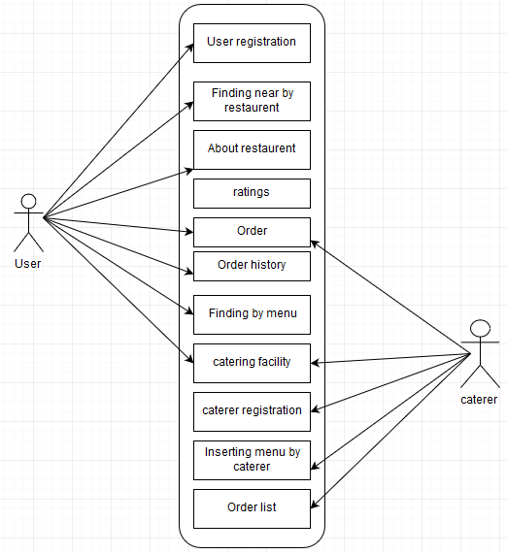

Use case description
Delete all the blue text and fill-in the template before adding this to your repository or turning it in to your instructor.

Use Case Number: | UC-01
Use Case Name: | User registration
Overview: | User will have to login (if not registered then sign up) to get access certain functionalities
Actors: | User
Pre condition: | He has provided a valid email and password
Flow: | Main (success) Flow:  - If user is not registered then he has to sign up by giving his name, phone no and email id.  - Then we send a message to his phone number to verify his genuineness.  - If he is already registered he can directly login.
 | Alternate Flows: Include the post condition for each alternate flow if different from the main flow.
Post Condition: | After logging to his /her they can order food or see their order history.

Use Case Number: | UC-02
Use Case Name: | Finding nearby restaurants
Overview: | User will be able to find the nearby restaurants if  he gives the locality name
Actors: | User
Pre-condition: | If he has provided a valid locality name.
Flow: | Main (success) Flow:  - If user enters a valid locality name and presses the submit button.  - He will get the restaurants list present in that locality
 | Alternate Flows: Include the post condition for each alternate flow if different from the main flow.
Post Condition: | User gets the list of nearby restaurants.
PS : possible that the locality name is actually present but may not be there in the database, then we will show operating locations of the app.
Use Case Number: | UC-03
Use Case Name: | About restaurant
Overview: | User will be know about the restaurant by selecting one of the restaurants from the list
Actors: | User
Pre-condition: | If he has provided a valid locality name and list of restaurants has appeared.
Flow: | Main (success) Flow:  - He will select one of the restaurants from the given list.  - The description about the restaurant appears i.e about menu,where it is exactly located….
 | Alternate Flows: Include the post condition for each alternate flow if different from the main flow.
Post Condition: | User gets the description of the restaurants.

Use Case Number: | UC-04
Use Case Name: | Finding nearby restaurants
Overview: | User will be able to find the nearby restaurants if  he gives the locality name
Actors: | User
Pre-condition: | If he has provided a valid locality name.
Flow: | Main (success) Flow:  - If user enters a valid locality name and presses the submit button.  - He will get the restaurants list present in that locality
 | Alternate Flows: Include the post condition for each alternate flow if different from the main flow.
Post Condition: | User gets the list of nearby restaurants.

Use Case Number: | UC-05
Use Case Name: | Order
Overview: | User after selecting the restaurant and the menu he will able be to order the food i.e.  he will able to place the order and he gets the summary of the order.
Actors: | User, Caterer.
Pre-condition: | Provided he is signed in.
Flow: | Main (success) Flow:  - If the user selects the dish and restaurant and clicks on the order button.  - He gets the order summary (like bill).  - A message will be sent to caterer that order is given by so and so person and the order will delivered to home or he can take away.
 | Alternate Flows: Include the post condition for each alternate flow if different from the main flow.
Post Condition: | User gets the order summary and tasty food to his home

Use Case Number: | UC-06
Use Case Name: | Order history
Overview: | User will be able to see the orders history.
Actors: | User
Pre-condition: | Provided is logged in
Flow: | Main (success) Flow:  - If user is logged in he can click the order history in the myaccount option.  - Then it shows the history of his/her orders.
 | Alternate Flows: Include the post condition for each alternate flow if different from the main flow.
Post Condition: | User gets his orders history.

Use Case Number: | UC-07
Use Case Name: | Finding by menu
Overview: | User will be able to find the nearby restaurants by the dish or cuisine
Actors: | User
Pre-condition: | If he has provided a valid locality name and dish/cuisine.
Flow: | Main (success) Flow:  - If user enters a valid locality name and dish name/cuisine presses the submit button.  - He will get the restaurants list which provide that dish/cuisine.
 | Alternate Flows: Include the post condition for each alternate flow if different from the main flow.
Post Condition: | User gets the list of nearby restaurants which are known for that cuisine or dish.

Use Case Number: | UC-08
Use Case Name: | Catering facility
Overview: | If a restaurant / hotel provides catering facility then the user can click on that restaurant and schedule when he wants the delivery, select the menu and message the caterer and caterer communicates with the user regarding this and the user can order.
Actors: | User, caterer
Pre-condition: | Provided he has logged in and clicked the restaurant which has catering facility and entered the details i.e. for how many people, what menu and which date…
Flow: | Main (success) Flow:  - If user entered above mentioned details.  - A message will be sent to the caterer regarding the order and then caterer can communicate with user about pricing ,dishes he want….
 | Alternate Flows: Include the post condition for each alternate flow if different from the main flow.
Post Condition: | User gets the confirmation from the caterer and then he can do payment.

Use Case Number: | UC-09
Use Case Name: | Caterer registration
Overview: | If a caterer wants to register he can register so that he can include his catering service in the app
Actors: | Caterer
Pre-condition: | Provided he is valid caterer.
Flow: | Main (success) Flow:  - Caterer/restaurant gives valid name, user name, registration for his catering service  - We verify this, and give him caterer/restaurant mode access.
 | Alternate Flows: Include the post condition for each alternate flow if different from the main flow.
Post Condition: | After registration Caterer or restaurant can put their menu and operate their door delivery service and caterer can take enable his catering services i.e caterer will be able to take bulk orders

Use Case Number: | UC-10
Use Case Name: | Insert menu by caterer
Overview: | Caterer can insert / update the menu can give his description i.e. contact details so that we can display it to the user.
Actors: | Caterer
Pre-condition: | Provided he is already registered
Flow: | Main (success) Flow:  1. To insert his details caterer first login with his caterer user id.  2. After this, he can update or insert his details or the menu as this will be show to the user.
 | Alternate Flows: Include the post condition for each alternate flow if different from the main flow.
Post Condition: | This details entered by him will be shown to the user when clicks about the restaurant.

Use Case Number: | UC-11
Use Case Name: | Order list
Overview: | Caterer will able to see how many orders he has received.
Actors: | Caterer
Pre-condition: | Provided he is logged in using his caterer user id.
Flow: | Main (success) Flow:  - After logging in If caterer clicks this order list he will get the list of what orders are given to him.
 | Alternate Flows: Include the post condition for each alternate flow if different from the main flow.
Post Condition: | Caterer will able to see the list of orders.

